YOOV OA – Rostering (Advanced) Module

Function:

1. Allow staffs working more than 1 pattern
2. Branch is required while setting up the work pattern
3. Establish the bounding with the work pattern and user’s salary (both basic salary and other salary) ** MUST
4. Publish Monthly or Periodic Roster to team members on list
5. Generate payroll file in accordance with the roster

System Setup

1. Work Pattern

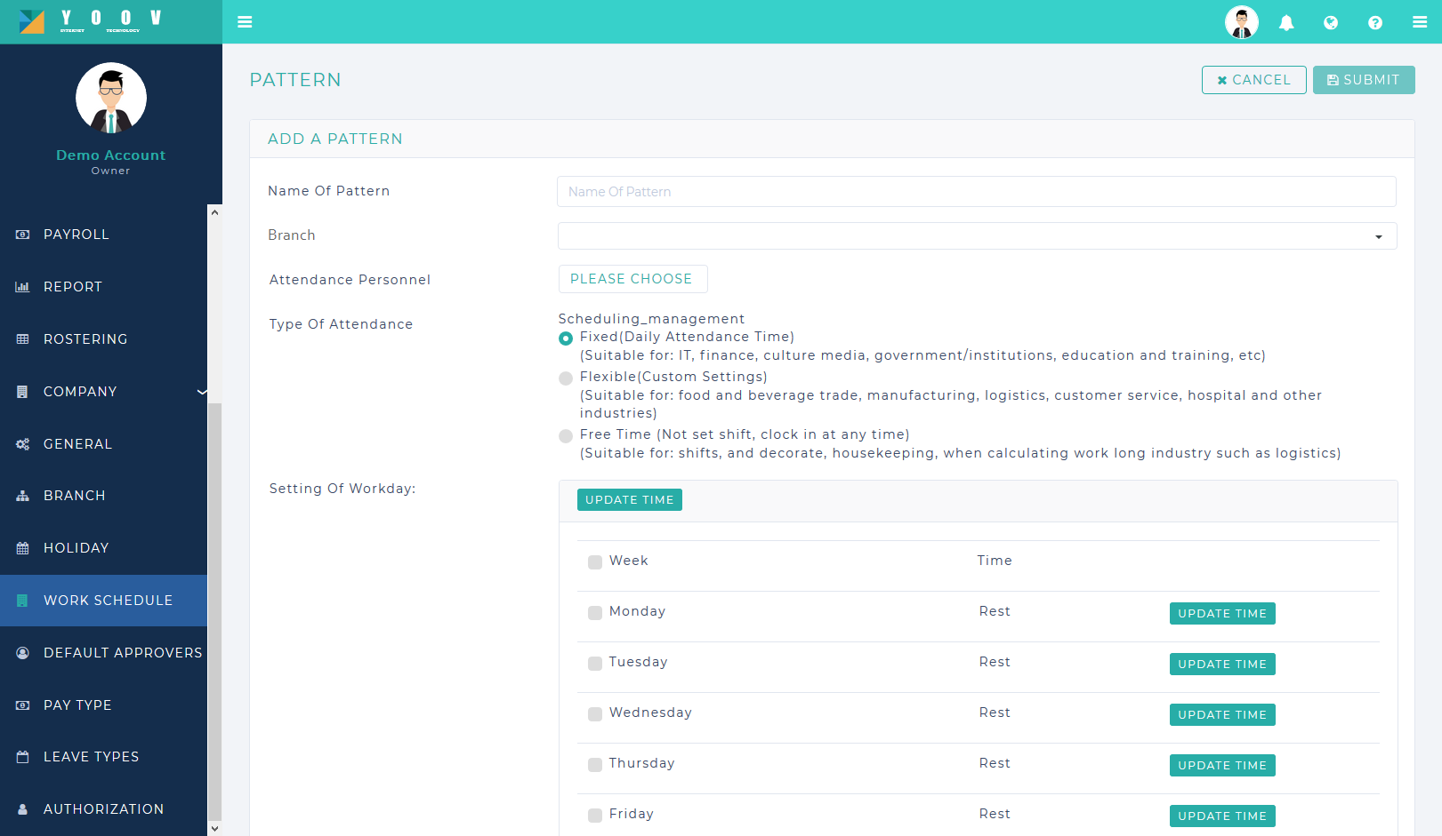

1. Salary/Other Salary

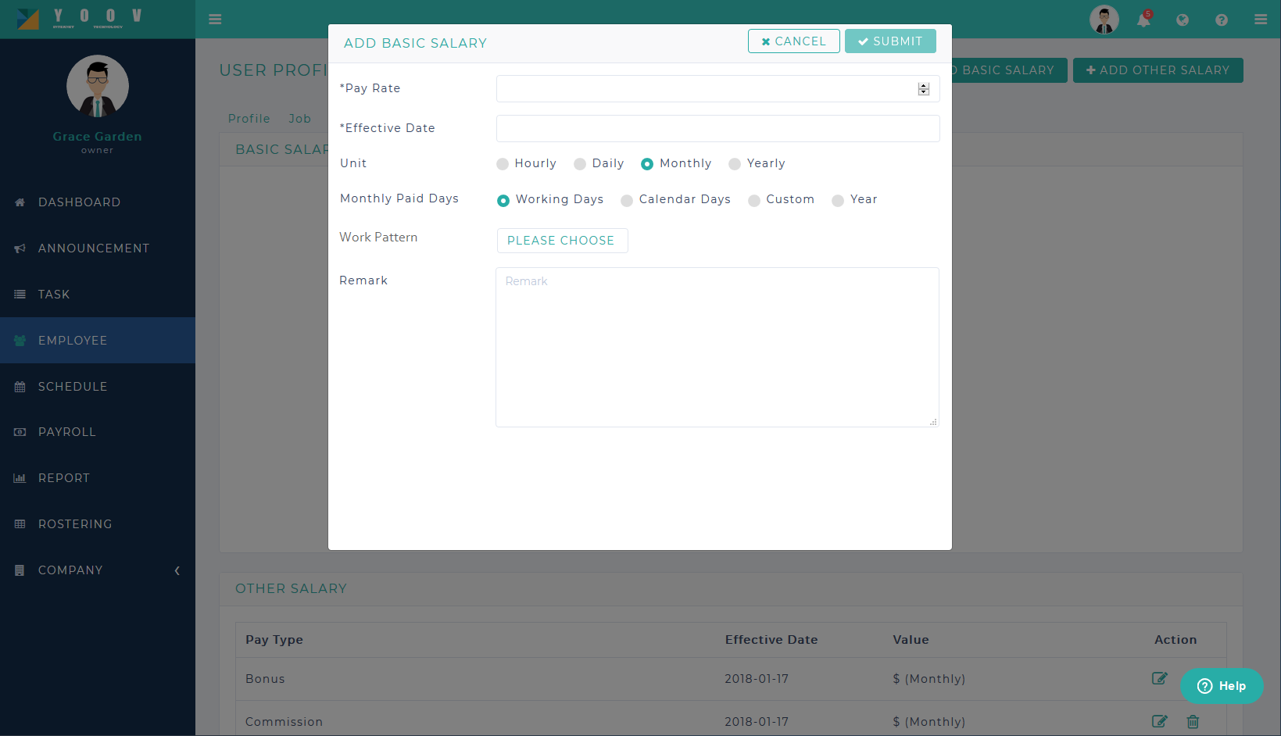

Work Pattern (PLEASE CHOOSE)

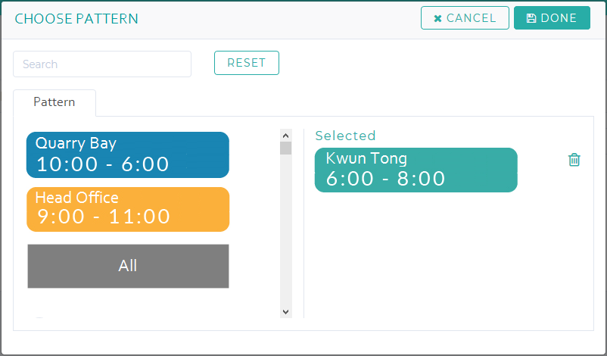

1. Rostering Tab

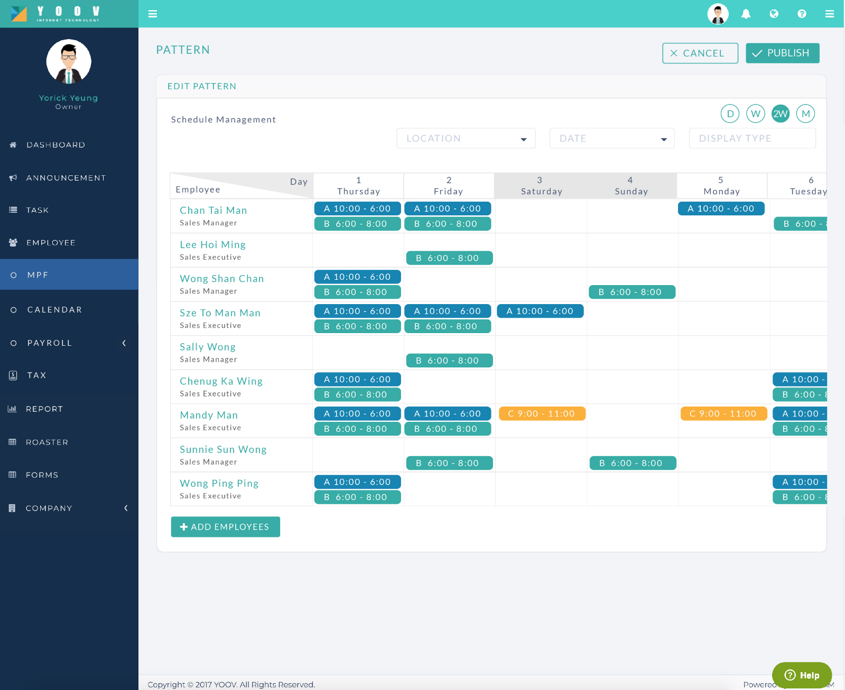

Note:

1) Please use the design from the work pattern above

2) Autosaving for each change

Add New Cell (include Rest or Paid Rest)

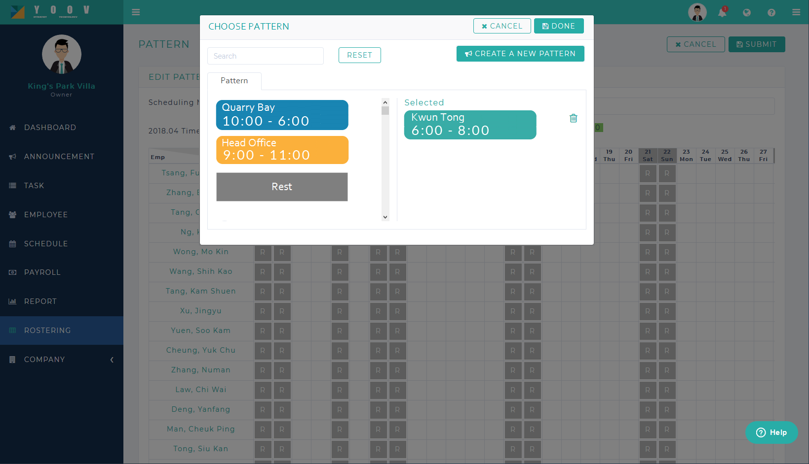

Phase 2

Replacement: For any reason, one employee is absent at work. Allow the user to replace that slot with another employee

|  |  |
| --- | --- |
| Staff | Working Hours |
| A | Not count |
| B | Count |

Make-up: Staff A has applied leave for time slot A and will work at time slot B as make-up

|  |  |  |
| --- | --- | --- |
| Staff | Time Slot A | Time Slot B |
| A | Not Count | Count |

Swap: Staff A & Staff B both swapped their time slots.

|  |  |  |
| --- | --- | --- |
| Staff | Time Slot A | Time Slot B |
| A | Not Count | Count |
| B | Count | Not Count |